**Course Code: CSE3150**

**Course Title: Front End Full Stack Development**

**Lab sheet 4 - Module 1**

**Problem Statement:** You have been tasked with designing a webpage for a new restaurant that will be opening soon. The webpage should showcase the restaurant's ambiance and cuisine using attractive visual elements.

**Note:** To create an appealing webpage for the restaurant, you can use various CSS3 features such as colors, text styles, transforms, and gradients. Here's a sample webpage design using these features:

Solution:

Code:index.htm

<!DOCTYPE html>

<html>

<head>

<link rel="stylesheet" href="style.css">

<title>My Restaurant</title>

</head>

<body>

<header>

<h1>Welcome to My Restaurant</h1>

<nav>

<a href="#h1">Home</a>

<a href="#m1">Menu</a>

<a href="#c1">Contact Us</a>

</nav>

</header>

<main>

<div id="grad2">

<h2>About Us</h2></div>

<p>My Restaurant is a new restaurant opening soon in your city. Our mission is to provide our customers with delicious food and excellent service in a comfortable and friendly environment.</p>

<img src="restaurant-image.jpeg" alt="Restaurant Image">

</div>

</main>

<h2 id="m1">MENU</h2

<section>

<div class="menu-item">

<img src="menu-item1.jpeg" alt="Menu Item 1">

<h3>pizza</h3>

<p>If you’re a vegetarian, you’ll love Domino’s Veg Extravaganza, Indi Tandoori Paneer, and Mexican Green Wave. For non-vegetarians, Non-Veg Supreme, Chicken Fiesta, and Indi Chicken Tikka top the list. Though these are the most loved Domino’s pizzas along with the cheesy Margherita pizza, you should check out the Domino’s menu to see what you like the most.</p>

</div>

<div class="menu-item">

<img src="menu-item1.jpeg" alt="Menu Item 2">

<h3>Burger</h3>

<p>Nine Different Types of Burgers to Make

Turkey burger. ...

Portobello mushroom burger. ...

Veggie burger. ...

Wild salmon burger. ...

Bean burger. ...

Cheeseburger</p>

</div>

<div class="menu-item">

<img src="menu-item1.jpeg" alt="Menu Item 3">

<h3>pasta</h3>

<p> here are some popular pasta dishes you might consider:

Spaghetti carbonara

Linguine with clam sauce

Fettuccine Alfredo

Penne alla vodka

Lasagna

Bucatini all'Amatriciana

Pappardelle with mushroom ragù

Rigatoni alla Norma

Spaghetti aglio e olio (garlic and oil)</p>

</div>

</section>

<section>

<div id="grad1">

<h1 id="c1"> contact us</h1>

</div>

<div id="rot">

<h1> feedback</h1></div>

</section>

<footer>

<p>&copy; 2023 My Restaurant</p>

</footer>

</body>

</html>

Output : style.css

/* General styles */

body {

font-family: Arial, sans-serif;

margin: 0;

padding: 0;

}

#rot{

transform: rotate(20deg);

}

#grad1 {

height: 200px;

background-color: red; /* For browsers that do not support gradients */

background-image: linear-gradient(blue, yellow);

background-image: conic-gradient(red, yellow, orange);

}

#grad2 {

height: 200px;

background-color: red; /* For browsers that do not support gradients */

background-image: linear-gradient(black, red);

}

/* Header styles */

header {

background-color: #333;

color: white;

padding: 20px;

}

nav a {

color: white;

text-decoration: none;

margin-right: 20px;

}

nav a:hover {

color: #ffcc00;

}

/* Main section styles */

main {

background-color: #eee;

padding: 50px;

text-align: center;

}

main h2 {

color: #333;

font-size: 36px;

margin-bottom: 20px;

}

main p {

color: #666;

font-size: 18px;

line-height: 1.5;

margin-bottom: 50px;

}

main img {

max-width: 100%;

height: auto;

margin-top: 20px;

box-shadow: 0px 0px 10px #333;

}

/* Menu section styles */

section {

display: flex;

flex-wrap: wrap;

justify-content: space-around;

background-color: #fff;

padding: 50px;

}

.menu-item {

flex-basis: 30%;

margin-bottom: 50px;

box-shadow: 0px 0px 10px #999;

padding: 20px;

text-align: center;

}

.menu-item img {

max-width: 100%;

height: auto;

margin-bottom: 20px;

}

.menu-item h3 {

color: #333;

font-size: 24px;

margin-bottom: 10px;

}

.menu-item p {

color: #666;

font-size: 16px;

line-height: 1.5;

}

/* Footer styles */

footer {

background-color: #333;

color: white;

padding: 20px;

text-align: center;

}

footer p {

font-size: 14px;

margin: 0;

}

/* Gradient styles */

header {

background: linear-gradient(to bottom, #333 0%, #666 100%);

}

nav a:hover {

background: linear-gradient(to bottom, #ffcc00 0%, #ff9900 100%);

}

section {

background: radial-gradient(circle, #fff 0%, #eee 100%);

}

.menu-item:hover {

background: linear-gradient(to bottom, #eee 0%, #fff 100%);

transform: translateY(-5px);

}

footer {

background: linear-gradient(to bottom, #666 0%, #333 100%);

}

Download :Restaurant image

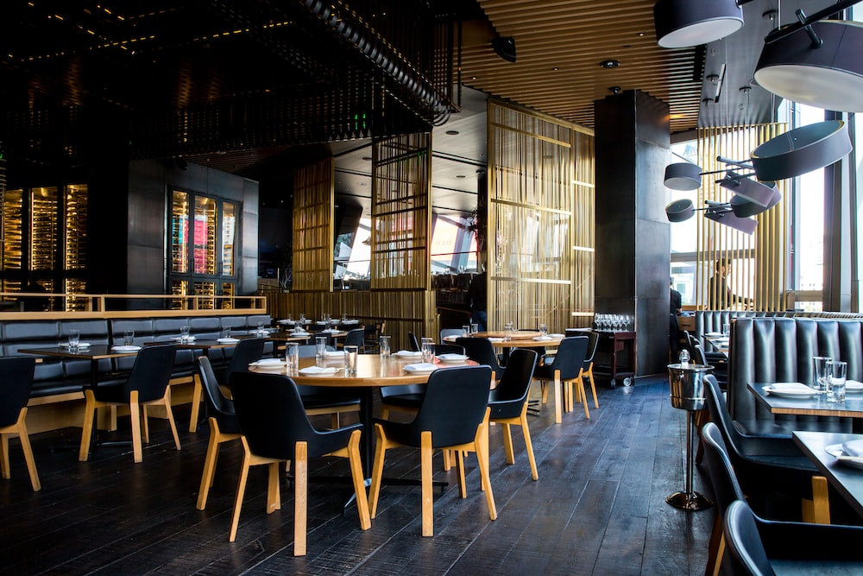

Output:

